All About Me!
My name is:
I like to be called:
I am: years months
I live with: | My pets are:
My favourite activity is: | 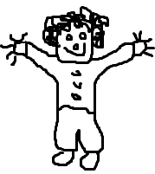  I am good at:
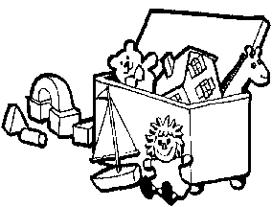  My favourite toy is: | I need help with:
I feel happy when: | I get upset when:
I am learning to: | I like to play with (friend/s):
I also want to tell you about:

CL/10

All About My Child
Child's legal name:
Date of Birth: Date completed:
Name of family members and significant people close to your child: | Any previous experiences of being cared for outside the home?
Does your child have any particular play  interests at the moment. | What sort of things does your child show  interest in or talk about?
Is your child used to being with other children and does he/she enjoy this? | How does your child respond to situations  and people who are new to him/her?
Do you think your child’s communication and language development is proceeding well? | Do you have any concerns or worries about your child’s development?
What does your child prefer to eat at snack and meal times? | Does your child have any particular fears, worries or dislikes we should know about?
Is there any other information you would like us to know in order to help your child settle and be happy at Mary Dean's Nursery?

CL/10

